ICTCS 2 - 9 inch Clamp
The ICTCS 2 is the larger version of a spring loaded clamping device with inter-changeable windows.
The ICTCS 2 fits on any Happy embroidery machine (HCS Voyager, HCD, HCR & HCG) with a 360mm (14 in) needle distance (hoop length) and installs the same as a plastic hoop. The larger format chassis accepts window sizes from 5"x 5" square to 7.5"x 6". Once installed, all you do is open the clamping window by rotating the handle down, insert your product and release the clamp. No more endless walking back and forth to your hooping table. You load and unload your projects at the machine itself!
The ICTCS 2 is ideal for larger embroidery designs. The larger windows allow designs up to 7.5" x 6" on tote bags, computer cases, left or right chest on insulated canvas jackets, blankets, duffle bags, etc.
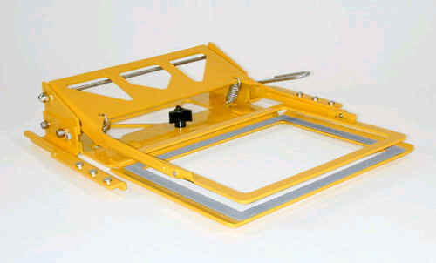 599321 - 9-inch Large Clamp Base
Retail Price Only $ 259.95
(Does not include windows)
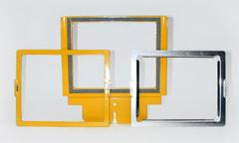

599324 - 7.5" x 6.0" Window Set (3PCS)
Retail Price Only $ 129.95

