E-Z FOLD

Innovative Automatic Textile Folders

Automatic Textile Finishing Solutions

Production & Packaging Equipment • Poly Bags Custom Machinery • Parts & Service

E-Z Fold

2000 and LS 4200

Operation & Maintenance

Manual

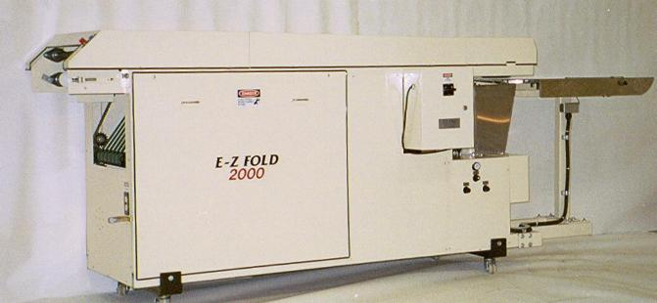

THIS E-Z FOLD MANUFACTURED FOR

MODEL: 2000

SERIAL NUMBER:

ELECTRICAL SPECIFICATIONS:

V ____ HZ. _______ AMP. ____ PH________

AIR SPECIFICATIONS:

100 PSI 5 CFM

NEDCO, Inc.
National Equipment Development Company

2485-B Lithonia Industrial Blvd
Lithonia, Georgia 30058
Phone (770) 484-9969
Fax (770) 484-9643
www.nedcofold.com

Technical Help-Line: 770-484-9969

MANUAL

The E-Z Fold 2000 is a simplistic design conveyor belt to belt design textile folder.

New concepts utilizing the latest solid state times and electric eyes are manufactured into this equipment. Linear actuated tuckers are constructed for fast adjustments, thus less production down time. The machine is sized to fit in small production floor space, yet can perform quality retail fold needs. High production rates can be accomplished thus fast payback results. Low maintenance and simple design is the key to the E-Z Fold 2000.

A variety of products can be folded on the E-Z Fold 2000. An in-line bagger/sealer can be added if ploy bagging is required. Qualified personnel can help fit the equipment needs with production needs.

Table Of Contents

1. Unpacking your equipment Page 4

2. Pre-Install Checklist Page 4

3. Setup / Installation & Layout Page 5

4. Safety Features Page 6-7

5. Operation & Controls Page 8-15

Includes: Intake Adjustments
Infeed Table Timer
Infeed Table Air Regulator
Infeed Air Gap Adjustment
Folding Plate Adjustment (Air)
Tucker Plate Adjustments
Folding Width Adjustment
Final Fold Adjustments

6. Maintenance Page 16-17

7. Conversions for garment thickness Page 18

8. Troubleshooting Page 19

9. Spare Parts Page 20

10. Product Set Up Chart

11. Electrical Diagram

UNPACKING EQUIPMENT

1. When your machine arrives, immediately inspect all your crates for any damage that may have occurred during shipping. If any damage is visible, make note of it and file a claim with the trucking company as soon as possible. All claims are the responsible of the freight recipient.

NOTE: Customers are expected to remove all equipment from shipping crates before the NEDCO technician arrives for installation.

2. Once you have placed the equipment near the operating location in your facility you can remove it from the crate.
- Remove all wood from sides and top of crate.
- Remove bolts and angle brackets from bottom of machine frame and skid.
- Use a forklift to raise the machine up and out of the crate.
- Place the machine in the location where you will be operating.
Note: If you have purchased the optional casters for the machine, you should bolt the casters to the frame using the same holes bolted to the angle brackets while the machine is suspended on the forklift. Fasteners need not be over tightened.
3. Remove top center b-panel and untie folding plate.
4. Cut tie wraps that have the infeed s.s. table secured.
5. Mount exit gray roller assembly on aluminum blocks located at exit end of folder.
6. Place product back stop on s.s. infeed table with arrow pointing toward pick-up point.
7. Remove left and right side panel and re-hand with supplied ¼ -20 fasteners.

PRE-INSTALL CHECKLIST

MACHINE SPECIFICATIONS FOR E-Z FOLD 2000

Weight – 1200 Lbs. 1000 KG
Length – 11Feet 3.5 Meters
Width – 2 Feet 60 Centimeters
Height – 50 Inches 110 Centimeters (Add 6 In./ cm for casters)
Floor Space Required – 20 Square Feet
Shipping Crate Size – 12’X6’X3’ 4mX2mX1m
Shipping Weight – 1600 Lbs. 1100KG

Electrical Requirements
Electrical Requirement – 110Volt 10-15 Amps. 220volt 5-10 amps

Air Requirements
Air Requirements – 100 PSI (Pounds per square inch) 2-3 CFM(Cubic Feet per Minute)

SETUP / INSTALLATION & LAYOUT

Locate your machine in a clean area. The folding machine is the last contact your product has before the customer sees it so it should be kept clean and in a clean environment. Below are two examples of how to lay out the E-Z Fold 2000 with the optional Unibagger II bagger/sealer and 6-l incline conveyor.

Layout #1
Max II

Dir. Of travel ➔
6-L Incline Conveyor

Direction of travel ➔
E-Z Fold 2000 and 4200

Direction of travel ➔

←-----------------------------------------------------20 Feet -----------------------------------------------→

Layout #2

Max II

Dir. Of travel ➔
E-Z Fold 2000 and 4200

Direction of travel ➔
6-L Incline Conveyor

Direction of Travel ➔

←-------------------------------------------14 Feet -------------------------------------→

SAFETY

In today’s working environment safety standards are very important. Because of this philosophy, the staff at NEDCO has incorporated many safety features into the design of its E-Z FOLD 2000.

First and foremost is the establishment of a clean, safe workplace. Consideration should be given to areas in which the machine is to be placed. Factors such as sufficient lighting and open accessibility to and from machine are noteworthy.

A safe work area can only be achieved by team effort. We encourage management to take an active role in this pursuit by establishing certain guidelines and procedures of a safety first attitude towards operation of this machine.

It is the sole responsibility of management and supervisory personnel to insure that all operators of the E-Z FOLD 2000 are qualified and properly trained in the proper operation of the machine and are aware of all safety features incorporated in the machinery’s design. NEDCO recommends a continual process of proper training of all personnel and encourages safety seminars on a regular basis.

SAFETY FEATURES

Emergency Stop Buttons:
These two twist lock style shaped red buttons have been strategically placed at the front and rear of machine. A simple push of either button will cut power to motor allowing machine to come to a complete stop. Turn counterclockwise to re-start machine.

Emergency Stop Buttons cut power off to motor only. Operators must be made aware that models constructed before 1998, the photo electric eyes are not affected by this shut down even though machine motor, chain, rollers and belts are no longer engaged.

Any movement across Infeed or second photo electric eye will result in travel of pneumatic cylinders. The main disconnect can be shut off to remove electrical power to these photocells.

Main Power Disconnect:
Prior to 1998 the disconnect is located on side of machine above main control panel. Pulling handle down to off position ensures complete power shut down of all machine controls. New models have the disconnect located as a black turn style located center door of the main control enclosure.

SAFETY FEATURES

Finger Guards and warning labels:
Located at in-feed opening of machine. Placement of this guard insures that controller or operators fingers do not come in contact with moving belts as garment moves into machine. NOTE: This finger guard is of a secondary measure, at no time should fingers come in contact with moving parts. The E-Z FOLD 2000 is a self-enclosed machine preventing personnel from being exposed to most major drive trains. Guards are placed at front and rear of machine as precautionary measures. At no time should operators be allowed in the vicinity of moving parts.

Side panels and chain guards are located externally and internally to prevent human contact. Chains are exposed for lubrication on moving clearance. At no times should an individual have machine running with panels or guards removed.

NOTE: Never remove any guards! Operating any machine without all guards intact will result in an unsafe and hazardous work environment.

Illustration and general machine description

Refer to this illustration to assist in familiarizing general parts and machine areas.
C-Panel Not needed A-Panel Infeed
Table

Infeed Photo Eye

Main Disconnect

Table Regulator
Pinch Point Regulator
Folding Plate Regulator

Product
Exit
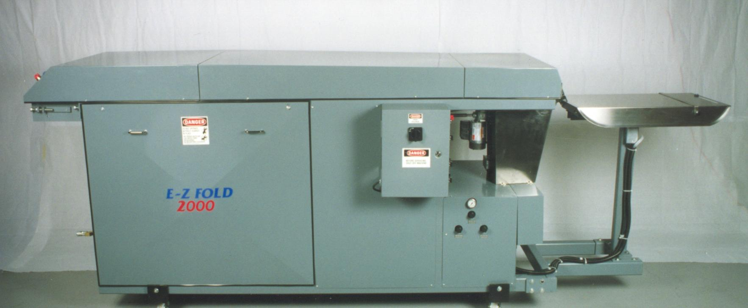

OPERATION AND CONTROLS OF E-Z FOLD

The following describes the control buttons and there function for the E-Z Fold 2000

Green On Button -Starts automatic folder motor / belts in motion.
Red Off Button -Stops machine and locks. Turn counterclockwise to reset.
Counter- Piece counter triggered by the second fold solenoid. Push button for reset.
Jog / Run Selector- When green on button is pressed and held while in jog position, machine will run. If green on button is released while in jog position, machine will stop. If selector switch is placed in run position and green on button is pressed, the motor starter will latch and machine will continually run after releasing green on button.
Infeed Table Delay Timer- This timer is an interval timer and wired in relationship to the infeed photo eye located in the slot on the Stainless steel in-feed table. The timer allows a set time for the in-feed table to travel in toward the pick-up pinch point before returning back for next product placement.

PRODUCT LOADING

Product Loading (Important: if production speeds are to be maximized, separation of inspection from product loading is necessary).

Operators can load the products on the stainless steel in-feed table from the left, right or rear of the table. Product mix and operator preference denotes the loading styles. Most E-Z Fold 2000's are loaded from the left or right side. Inspecting must be separated from production loading of folder. Most products (especially short sleeve garments) are draped in the space between the stainless steel table the pick-up point, then pulled back to a center line on the adjustable back stop. There will be more discussed on the back stop later.

ADJUSTMENTS

STAINLESS STEEL INFEED TABLE

Product Back Stop:

The Stainless Steel infeed Table is located at the front of the machine. It is important to note at this time that since this is where the folding sequence begins it is crucial that in order to insure a quality consistent fold the garment must be placed on table correctly. A cross bar product backstop is provided with the E-Z Fold 2000. The main function of the cross bar is to regulate the length and centering of final fold of garment. Loosen the black adjustable thumbscrews to slide bar forward of backward. Adjustments of this bar determines the amount of material that will be placed on table, any excess material will ultimately drape over edge of table and be folded under when contact is made at Infeed Roller Pinch Point. There must be 2-3 inches of material draped over to successfully fold under.

Example: If the final fold length of garment to be folded is 10 inches then twice that amount should be placed on table, loosening thumb screws on adjustment bar and sliding bar back 20 inches from folding edge will insure that 20 inches of material is placed on table resulting in a final fold length of 10 inches.

A center mark has been placed on this adjustment cross bar. This allows the operator to place the center of garment over the center mark thus insuring that garment is fed into machine in a straight and centered profile. It is the responsibility of each operator to insure that the garment is placed correctly on infeed table. Supervisory personnel need to be aware that operators must be sufficiently trained in this procedure. Since the folding sequence begins at this point, it is crucial that placement of garment be made correctly.

Infeed Photo Eye Cycle Start:

An electronic photo eye is located in slot of table. This eye is refractive sensitive. As operator crosses the path of eye with his or her hand, a signal is sent to timer. An operator must pass within 2” for the sensor to function. which then starts the Infeed cycle. (This cycle consists of table traveling forward with garment being fed to machine then returning to ready position).

IN-FEED PRODUCT PICK UP ADJUSTMENTS:

- Proper intake roller gap and depth of feed tray travel depend on specific product configuration. In general, intake gap ranges from (0) to 3/8”. Thin products require less gap space than bulky ones. The ideal gap is 1/16” for T-shirts.

2. Feed table should enter gap at center of pinch point. Feed tray should never hit upper white belt pick-up roller or seven lower green belt pick-up roller assembly.

3. Depth of in-feed tray travel depends on product bulk, on whether or not cardboard inserts are used, and on method of infeed. Generally, thin products will require deeper travel than bulky ones. The infeed timer and the infeed photo eye cycle start are in direct relationship to the depth of travel. The timer is an ON DELAY solid state component which energizes when photo eye is passed over within 2 inches. Machines not using cardboard feed may require deeper travel. Products can be laid on infeed table with out being draped over. Enough material must be exposed for pinch point to pick garment up.
Intake gap ranges from 0 to 3/8”

Thin products require less gap space than thick products.

Example: Ideal gap for T-Shirts is 1/16”

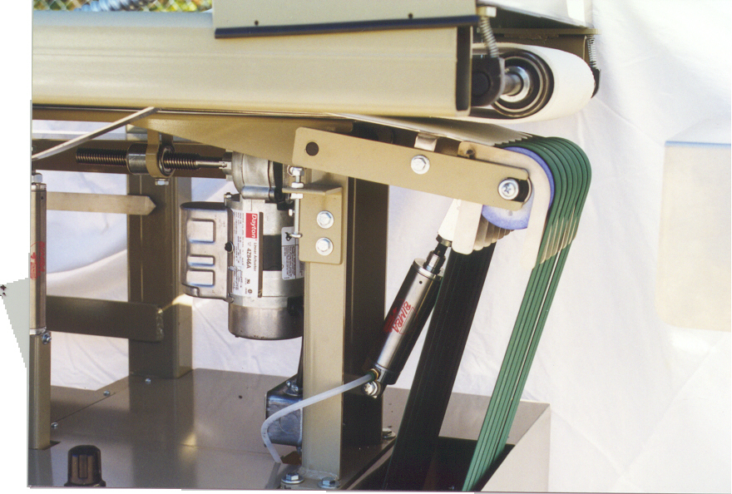
Infeed Table Timer:

The purpose of this timer is to regulate the travel distance/time of Infeed Table. Average timer range for short sleeve T-shirts is around #1. This Timer engages when the infeed photo eye is passed over. Pressure of infeed table regulator and the adjustment of the infeed tables cylinders flow controls are a major function of the travel time of the table. The flow controls are set at the factory for table speed and travel based on 40 psi at the infeed regulator. Never the less if this timer is set incorrectly, two conditions could result.

1. If the timer is set too low, it will not allow table to travel forward far enough to be fed into first pinch point of machine.

2. If the timer is set too high the table will travel forward. Garment to be folded will be fed into machine but return cycle of table will be slow. Increasing the infeed timer is
generally performed when prefolded long sleeve products are presented to the infeed table.
Infeed Table Air Regulator:
The travel of Infeed table is controlled by an air cylinder, in order for this air cylinder to work properly it must be supplied with a constant air supply. The Infeed Table air Regulator regulates this air supply. Operator should set between 35 to 40 P.S.I.

IMPORTANT:
Infeed Table should never be allowed to travel past garment pick up point. Improper pressure adjustment and height adjustment may result in Stainless Infeed Table coming in contact with folding belts causing excessive damage to belts. Only trained personnel should monitor and make adjustments.

Infeed Air Gap Regulator Adjustment:

This adjustment is made by a manual adjustment regulator w/gauge located on left side toward front of machine. (NOTE: the gauge pressure is not important. The gap relationship to the white upper drive belt and the lower seven green belts is most critical). Increasing pressure will shorten gap; decreasing pressure will lengthen gap. Reference point is about a 1/16th-inch gap between white folding belt and green infeed belts. This is a standard gap for most T-shirts depending on the thickness of material. Thickness of material of garment to be folded is the primary consideration when making this adjustment. Proper adjustment of this gap plus proper adjustment of Infeed Table height will assure that table does not come in contact with either belts. It is important to note that if garment to be folded is of a thicker material, gap should be increased to compensate for this difference. This is a visual adjustment not accomplished by reading the pressure gauge. 1999 models have the pressure gauge removed.

Folding Plate Pressure Lift/Support Adjustment:

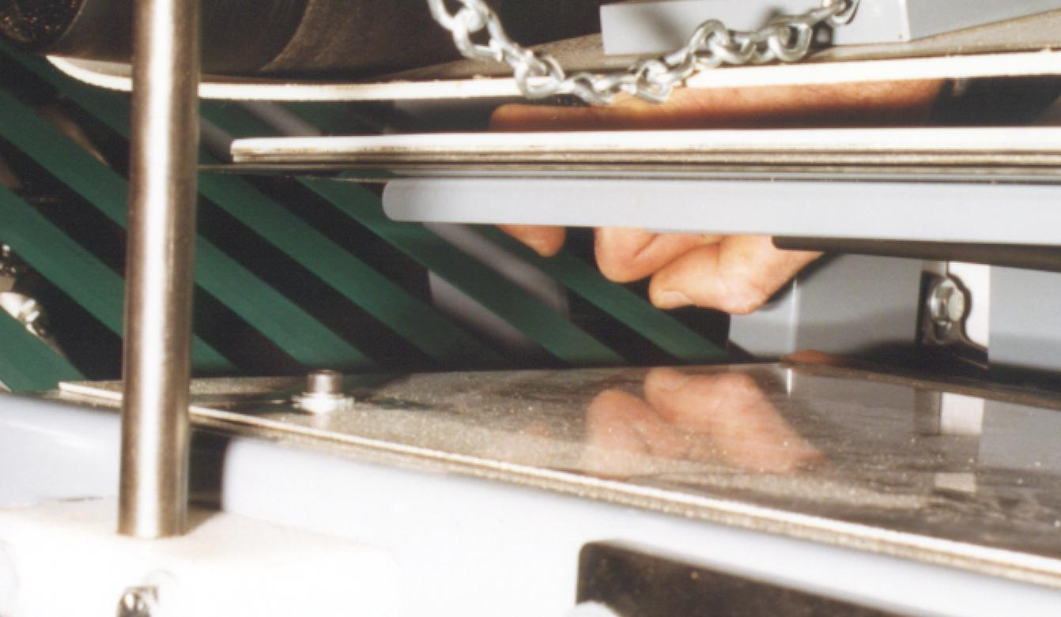
Located to the left of the Infeed Air Gap adjustment regulator is another manual adjusted air regulator. This is the Folding Plate Rear Gap Adjustment. This must be set by visual reference only. The folding plate is very heavy and is suspended 2/3 the length of the folding machine. The result is the plate can drop down and form air space at the discharge end of the plate. Zero air space at the discharge end of the plate is good. Again, visual reference is the only way to accomplish this adjustment. Too much pressure will cause excessive wear to the belt and the folding plate.
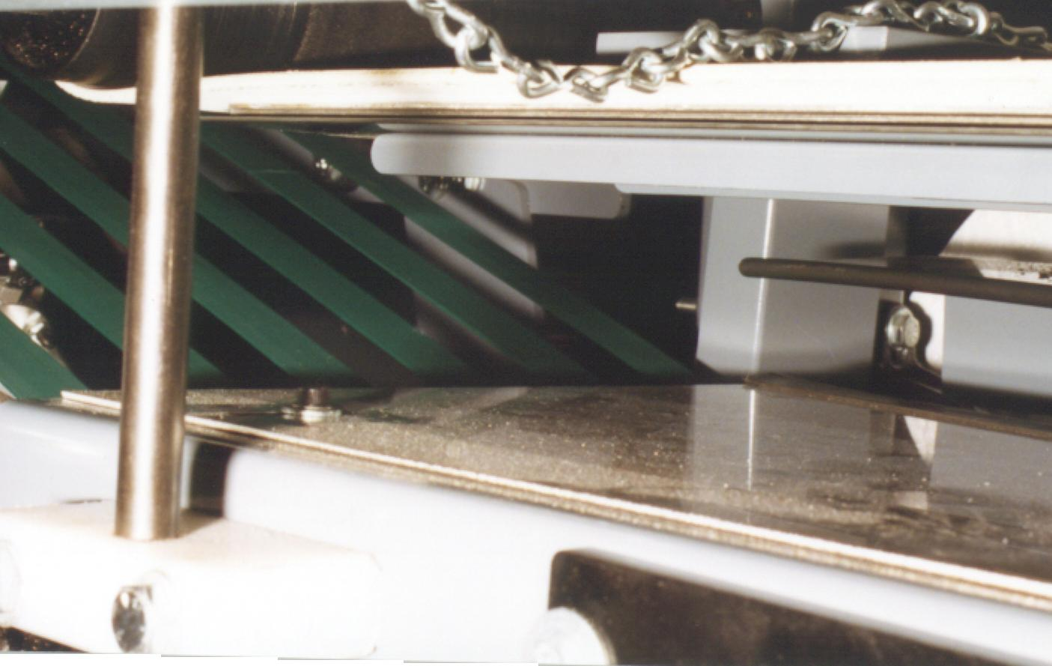
Correct Incorrect

Folding Plate Pressure Lift/Support Adjustment: Continued

One consideration both adjustments share is the thickness of garment to be folded. The main purpose of the Folding Plate rear gap adjustment Valve is to insure that there is a constant pressure of folding belt upon garment while it travels on folding plate through its folding cycle. It is the constant pressure of the folding belt against the garment riding on folding plate that transfers garment from front of machine toward rear of folding sequence. The initial setting is to bring folding plate against folding belt, this will then provide constant pressure on garment to be folded. If garment seems to bind and show signs of excessive wrinkling this would indicate that this rear gap is to close and should be opened in small increments until a satisfactory fold is achieved. If garment seems to hesitate toward rear of folding plate or stops all together this would be an indication that gap is too loose and should be reduced, once again these adjustments should be made in small increments until a satisfactory fold is accomplished.

FOLLOWING ADJUSTMENTS LOCATED ON RIGHT SIDE OF MAIN POWER BOX.

Right Tucker Plate
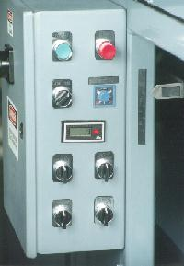
Manually adjusted by operator, turning spring returns knob upward or clockwise raises plate, turning knob downward or counterclockwise lowers plate. Each machine has a numbered scale for adjustment charting. A good reference point: set at #2(See Photo) is for most medium material T-shirts. Thick material garments would require a larger gap.
Left Tucker Plate
Adjustments: Same as Right Tucker Plate.
Left Tucker Reference Point #2

Sleeve Tucker

Adjustments: Same as Right Tucker Plate.

NOTE: Right Tucker Plate; Left Tucker Plate and Sleeve Tucker are all set at a reference point of #2 these settings are usually the best settings for a wide variety of thickness and styles, however some experimentation in these settings are encouraged. Any changes in these settings should be done in small increments.

Diagnosing Plate Adjustments

The best way to determine if all three adjustments are correct is to take the garment that has been completely folded and start to slowly unfold it. If left side of shirt shows signs of excessive wrinkling then this is a good indication that left Tucker Plate is adjusted to tightly and should be lowered. If left side is not being folded completely under shirt this is an indication that Left tucker Plate needs to be raised allowing greater contact with material and tucker plate.

These indications and remedies are the same for the Right Tucker Plate.

Any sleeve material being exposed after final fold indicate that the Sleeve Tucker needs to be raised thus allowing Sleeve Tucker to engage sleeve and tucking completely under garment leaving no exposed material.

NOTE: Right and Left Tucker can also be moved in or out toward center of machine. Remove center top cover and loosen socket head screws to make this adjustment.

Folding Width

Numbers are located on the actuator motor that controls the folding width, turning knob upwards/clockwise increases folding width. Turning control knob downwards/counter clockwise decreases folding width.

Final Fold Adjustment

As garment travels along folding plate and reaches the end, it is then transferred to green lower second fold belts. At this point the garment is almost completely folded, the right side, left side and sleeves have been folded. Garment is on its way to the final length fold and exiting machine. After garment has been transferred to green belts it is guided toward an electronic photo eye. Once the garment has crossed the path of the eye a signal is sent to the second fold timer which in turn causes final fold fingers to travel up, thus making contact with garment at precise moment. It is the setting of this rear timer that determines the exact location where final fold will be made. If the final fold is made too early, then more time should be adjusted at timer. If the final fold is made too late, then time should be reduced.

Proximity Switch

As final fold fingers begin their journey in an upward motion they ultimately cross the path of the Proximity Switch. As the proximity switch senses the location of the fingers, it in turn sends the final fold fingers down to the ready position.

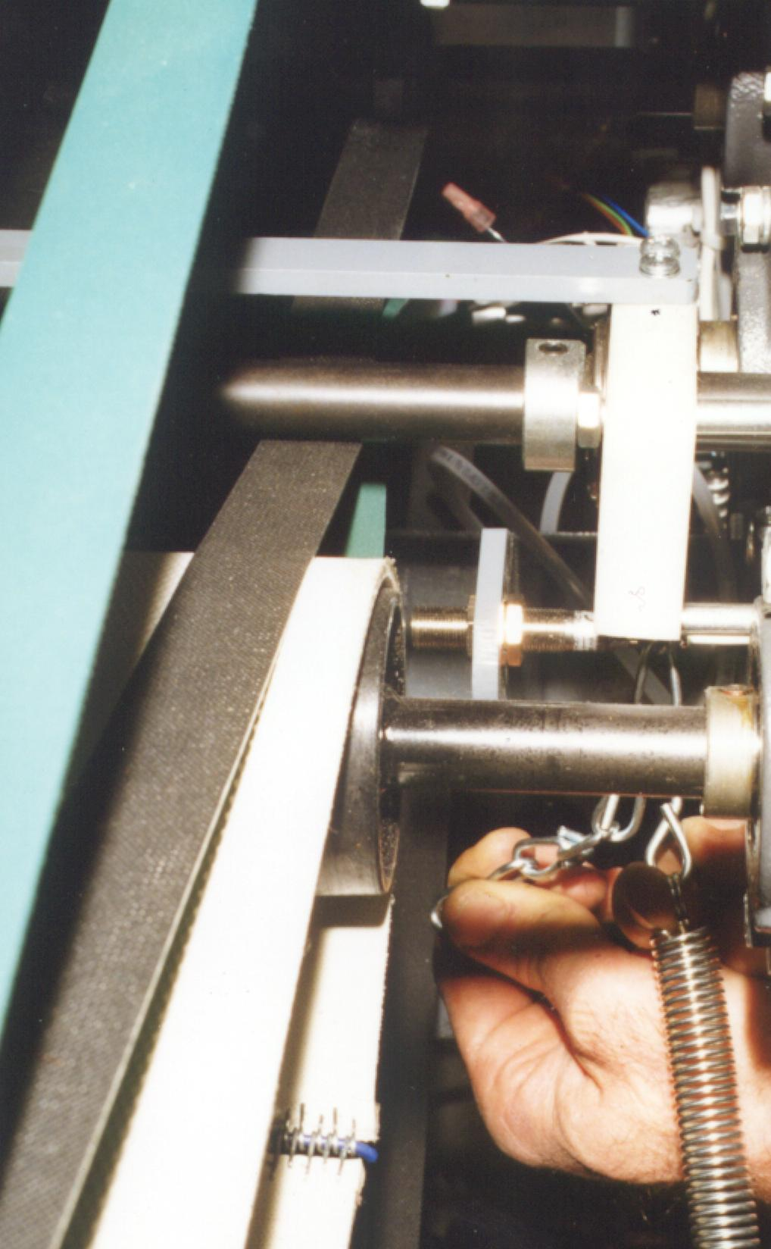
NOTE: There is a direct correlation between amount of material being placed on Infeed Table and adjustment of rear timer. Once settings have been made for a certain garment there should be no reason for re-adjustment. If the garment to be folded is placed on table at exactly the same position every time and rear timer is set correctly, then there will always be a consistent final fold. However, if operator changes this position it will result in a constant need to change settings of rear timer.
Rear Upper Tension Roller Adjustment

It is the purpose of this roller to encourage garment to make the final turn allowing final folding fingers to fold garment. If this setting is not correct, garment will exit machine without being folded in half. It is the placement of a spring on chain loops that determines tension exerted on garment. Any changes to this tensioner should be in small increments only. Thicker garments, like sweats, will require less pressure and thinner material garments, like Tees, will require more pressure.

Chain Adjustment
Prox Switch

CONSIDERATIONS FOR THICKER GARMENTS

1. Infeed Air Gap Adjustment: This gap must be increased or opened up in order to allow a thicker garment to be picked up by folding machine.

2. Folding Plate Adjustment: This adjustment is made by increasing or decreasing the air pressure of the regulator that controls the folding plate rear gap adjustment. Change over from folding T-shirts to thicker garments or sweats would require that operator increase the gap between folding and white belt at rear of folding plate.

3. Right Tucker, Left Tucker & Sleeve Tucker: The adjustments of these controls should result in increasing the distance between each other. This will allow thicker garments to pass between these plates without creating any binding of material and thus resulting in a consistent, quality fold.

4. Rear Upper Tension Roller Adjustment: Reducing pressure or tension of this roller bar should be made in small increments. This adjustment is made by uncoupling spring from adjustment chain and hooking spring to different chain link. Loosening this tension will reduce pressure applied to garment, it is important to know at this time that the pressure of the roller upon the belts should only be enough to allow garment to receive its final fold. Any pressure above this point is not recommended and will result in an unsatisfactory fold.

5. Proximity Adjustment: Lower the prox switch to prevent the thicker product from jamming at the second fold exit point. The fingers will not stock at far, therefore allowing the thicker product to exit smoother.

MAINTENANCE AND LUBRICATION SCHEDULE FOR E-Z FOLD 2000

1. Maintenance requirements on the E-Z Fold 2000 Folders are
relatively few for a production line machine.

2. General Daily Maintenance Schedule

A. Check that all belts are tracking properly.
B. Check Chains for tension adjustment.
C. Blow machine down daily to remove dust, lint etc.

3. Lubrication Schedule

A. Weekly: (after 60 days of operation)
- Lubricate all chains with lite chain oil or equivalent.
- Tighten all chains with take up idler sprockets. (See Photo)
- Lubricate infeed table slide rods with white lithium grease.
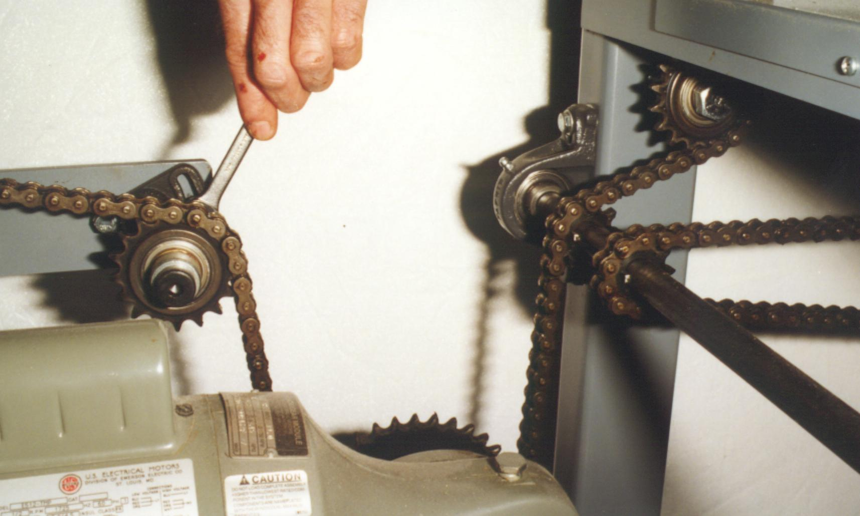
Idler Sprocket take-up adjustments.
1 of 2

- 1st year after 6 months: change gear oil in gear motor, then once a year
there after. Standard 80-weight gear oil is acceptable.

C. Six Months: (more frequently if running more
than one shift daily) Check all belts for contact
wear and tightness.

MAINTENANCE SCHEDULE

Description Weekly Monthly Annually

Change oil in main X
Gear Box

Oil #40 Chains X

Oil Infeed Table Rods X

Check belt tension X
and alignment on
white Main drive 8" wide white and
12" wide white exit belts.

Check both chain tension X

Check Green Belts X
for wear and alignment

Tighten set screws on Bearings X
& sprockets

Grease bearing X

CONVERSIONS TO BE MADE WHEN THERE IS A LARGE VARIATION IN GARMENT THICKNESS:

1. Tucker Plates should be opened wider to allow the garment to move more freely
along the folding plate.

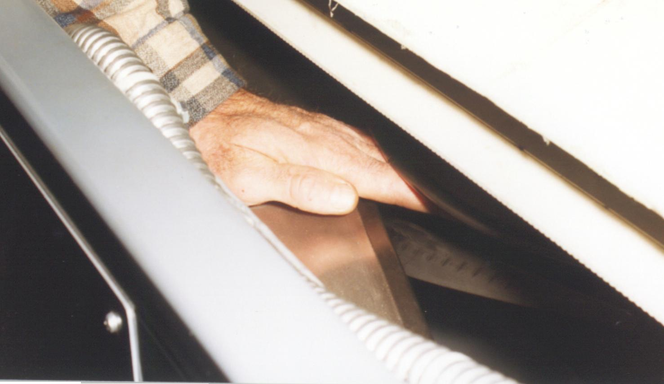
Right Tucker Plate

Left Ticker Plate

2. Fold Plate adjustments/ 5"-10" folding plate.

3. Sleeve Tucker should be lowered for thick garments.

4.Tucker Plate extension should miss carrier belts approximately 3" with thick
garments. Extension plate should only miss carrier belts by approximately ½" with thin garments.

5. Proximity Switch should be aligned with lower mark on mounting bracket for
thick garments and upper mark for thin garments.

6. Spring Tension on final pinch point may need slightly less tension for thicker garments.

Note: All the adjustments are based on samples tested at the manufacturer.

TROUBLE SHOOTING E-Z FOLD 2000

Problem Possible Cause Remedy

In-Feed table does Insufficient air pressure Check feed table
not move to feed table, cylinder air pressure
regulator (Reg.2)
Set to 20-40 PSI.

Incorrect flow control Adjust flow
adjustment control needles
toward "fast"

Defective Solenoid Check, repair,
or replace

Defective Cylinder Check, repair,
or replace

In-Feed table too Incorrect flow control Adjust feed table
slow on forward setting cylinder flow production stroke affecting
needle valves

In-Feed too slow Incorrect flow control Adjust feed
on back stroke table
Setting affecting production cylinder flow
needle valves

In-Feed table Incorrect flow control Adjust feed
bangs on forward setting table
stroke cylinder flow
control V-21

Product stalls Insufficient clearance Adjust linear
in horizontal actuator
fold section left,right
sleeve as necessary

Main product drive Increase belt slippage

Problem Possible Cause Remedy

Product stalls Vertical side guides Adjust vertical in horizontal too wide side guides
fold section (Cont’d) inward

Vertical tucker plate Adjust Linear
clearance too great Actuators up as
necessary

ANY QUESTIONS ON THE FOLDER, BAGGER, SEALER OR INCLINE CONVEYOR SYSTEMS, PLEASE CALL OR WRITE TO THE BELOW ADDRESS.

E-Z FOLD 2000-MANUFACTURED BY NATIONAL EQUIPMENT DEVELOPMENT COMPANY (NEDCO) 2485-B Lithonia Ind. Blvd., LITHONIA, GA 30058
PHONE #770-484-9969 ( plant)

Below is a recommended Spare Parts list for the Folding Equipment. If you have any questions, give me a call
at 770-484-9969.

Drawing
Ref. PART # DESCRIPTION QTY Please Call or E-mail for
Prices – don@nedcofold.com

1 SB-46 In-feed Belts 1 Set

2 SB-48 Upper Exit Belts 1 Set

3 SB-60 Lower Exit Belts 1 Set

4 SE-1 Infeed Photo Eye 1

5 SE-2 Second Fold Photo 1

6 SE-3 Infeed Timer 1

7 SE-4 Second Fold Timer 1

8 SE-5 Proximity Switch 1

* Parts are in stock and available for immediate delivery
* Spare parts are quoted F.O.B. Atlanta, GA.

FOLLOWING IS A LIST OF THE MOST COMMON ERRORS AND
PRACTICES OF OPERATORS OF THE E-Z FOLD 2000

1. Quality Control: Proper placement of shirt on stainless steel infeed table, final length of garment is determined according to placement of cross bar on stainless steel infeed table. Thumbscrews can be loosened and bar moved to its desired location, as a reference ½ of the total length of material placed on table will be the final fold length. A center mark should be placed on this cross bar, this will allow the operator to center the shirt to the center mark.

2. Front Air Gap: It is important to understand that some gap between from green belts and white folding belt must be present at all times. A 1/8th-inch gap is a reference point for most T-shirt applications, thicker garments would require a slightly larger opening.

3. Rear Air Gap: Proper adjustment will insure that constant pressure is applied to shirt during its folding sequence, in most applications no gap would be evident. Thicker garments such as sweatshirts would require some gap understanding that binding of garment could result if to much pressure is applied to garment.

3. Folding Plates: Numerical plates are placed at indicators for left tucker, right tucker, sleeve tucker, for most T-shirt applications setting all three to the #2 positions is a general reference point. This allows space between all plates to prevent any unnecessary pinch points or binding of material.

4. Tension Roller: The tension roller is the force being applied to the garment that encourages the garment to slope down allowing final fold fingers to fold garment in half. Only enough pressure needed to allow this process is necessary. Any excess pressure will result in premature belt wear and an undesirable fold.

6. Chain Adjustment: Part of the maintenance schedule should include proper adjustment of chain and verification of proper sprocket wear.

7. Lubrication: Lubrication of all bearings, chains, sprockets and moving parts are crucial to a successful maintenance program.

Uncrating and Installation

- Inspect crate and machine for damage during shipping, call shipping company immediately if any damage is found. Call a N.E.D.C.O. representative immediately if shipment is damaged. #770-484-9969
- After inspection machine can then be uncrated and placed on casters or in area that has been pre-determined. If desired wood can be used if casters are not.
- Customer can use 4” by 4” boards of crate to set machine on. This provides for optimal height of folding machine. Cut quantity of two (2) boards 4” wider than machine and place under machine. Folder, bagger, and incline can be set up inline or 90 degrees from folder exit grey roller end. (optional)

Parts supplied in box with machine.
- [1] Exit discharge gray roller assembly must be mounted at exit end
- [1] Place product back stop with arrow on S.S. infeed table
- [1] Air Coil Hose mounts between folder and sealer (optional)
- [1] Outlet power extension. cord. Plugs into folder at rear for folder (optional)

IMPORTANT:
- Folding plate has been tied for shipping purposes and must be untied before power-up. Customer must remove center top B-panel to access this tie.
- Do not operate machine until you untie Folding plate!!!!!
- Tuckers (right, left and sleeve) have been moved from the # 2 position for shipment. #2 is best for T-shirts.
- Set fold width to desired specification.
- Wood sometimes has be jammed under tucker and/or tuckers and must be removed .
- Remove screws in both side panels and hang back in place for ease of access.
- Cut tie wraps on S.S. infeed table.
- Cut tie wraps on infeed emergency stop switch.

Supply the following utilities:

The specified electrical voltage must be supplied to machine and 100 P.S.I. 4-5 C.F.M. clean dry compressed air in male connector of folder.

E-Z FOLD

Innovative Automatic Textile Folders

Automatic Textile Finishing Solutions

Production & Packaging Equipment • Poly Bags Custom Machinery • Parts & Service

E-Z Fold

LS 4200

Long Sleeve Attachment

Operation & Maintenance

NEDCO, Inc 2485-B Lithonia Industrial Blvd., Lithonia, GA 30058 #770-484-9969, Fax #770-484-9643

(1)

SAFETY

In today’s working environment safety standards are very important. Because of this philosophy, the staff at NEDCO has incorporated many safety features into the design of its E-Z FOLD.

First and foremost is the establishment of a clean, safe workplace. Consideration should be given to areas in which the machine is to be placed. Factors such as sufficient lighting and open accessibility to and from machine are noteworthy.

A safe work area can only be achieved by team effort. We encourage management to take an active role in this pursuit by establishing certain guidelines and procedures of a safety first attitude towards operation of this machine.

It is the sole responsibility of management and supervisory personnel to insure that all operators of the E-Z FOLD are qualified and properly trained in the proper operation of the machine and are aware of all safety features incorporated in the machinery’s design. NEDCO recommends a continual process of proper training of all personnel and encourages safety seminars on a regular basis.

SAFETY FEATURES

Emergency Stop Buttons:
These two twist lock style shaped red buttons have been strategically placed at the front and at the infeed pick-up point. A simple push of the red button or the infeed plastic guard will cut power to motor allowing the LS 4200 and EZ Fold Automatic Folding machine to come to a complete stop. Turn counterclockwise to re-start machine.
IMPORTANT: The Infeed stop turns the motors off, but not the air operations.

Emergency Stop Buttons cut power off to motor only. Operators must be made aware that models constructed before 1998, the photo electric eyes are not affected by this shut down even though machine motor, chain, rollers and belts are no longer engaged.

Any movement across Infeed or second photo electric eye will result in travel of pneumatic cylinders. The main disconnect can be shut off to remove electrical power to these photocells.

(2)

Attaching the LS 4200 to EZ Fold 1000 or 2000 Models

The LS 4200 Long Sleeve Attachment is a patent pending design, which can be used with the NEDCO EZ Fold 1000 or 2000 models. The 2000 model is slightly wider and has better adaptability. Both the E Z Fold 1000 and 2000 operate the same. They both have (4) four actuators for quick adjustments and solid state electronics for long lasting life and maintenance free service. Load the SS Product Table with your products as before. Cycle start with a Photo Eye as before.

Operation of the LS 4200
Again the Infeed Table loading is the same on the LS 4200 as with the EZ Fold 1000 or 2000 models.
The LS 4200 does have below the Infeed Table two round Stainless Steel Long Sleeve guide rods. These allow for long sleeves to transfer into the pinch point smoothly without crashing into the Stainless Steel lower Infeed Guard as the table re-tracks.

Old or Past Infeed Pick-up Belt Gap Area:
The EZ Fold 1000 or EZ Fold 2000 standard product pick-up point is now a transfer location with LS 4200 in place. (4) Four Green belts move from the LS 4100 over this area. No longer is a (7) Seven Green Belt design used.
Important: This above mentioned pick-up point should be regulated with a larger gap now with LS 4200 in place. ½" opening is good. You perform this function the same as before with the original infeed pinch point regulator. This is a visual operation.

New Infeed Table LS 4200 Pick-up Belt Gap:
Important:
The gap should be set at 1/8” to 1/4" for T-shirts and slightly more ( 3/8” to ½”) for fleece or thicker garments. You adjust this gap wider by adjusting the New LS 4200 Infeed Regulator located at the bottom of the SS Infeed Belt shroud.

Turning on the LS 4200 Round Tucking Belts:
With all E-Stops released and the EZ Fold 1000 or 2000 running, you can then turn on the LS 4200 Round Long sleeve Tucking Belts. You can find a selector (on/off) switch on the left side of the LS 4200 near a Red E-Stop Switch on the Variable speed controller control box.. Remember this E-Stop is now wired in with the other E-Stops on the Folders and must be twisted out to turn the folding machine(s) on.
Variable Speed Controller: This allows for the Green long sleeve tucking belts to run at different tucking speed rates. The faster the belts are running, the more the long sleeves are tucked lower to the back garment body. The slower the belts run, allow for the sleeves to be tucked higher to the back garment body.
Important:
Remember to turn on both the E Z Fold Automatic Folder and the LS 4200 round Tucking Belts. If you have an EZ Fold 1000 or 2000 now, you perform this as before by pushing the green button on the folders left side on Control Box. You can leave LS 4200 Round Tucking Belts running for both long and short sleeve products.

(3)

Long Sleeve Tucker Arm Adjustment:
Located on the left and right side of the LS 4200 and above the angled green round long sleeve tucker belts are the Long Sleeve Guide Tucker Arms. These Arms are adjustable in and out from the centerline of the LS 4200. Each arm has (2) two wing nuts holding them in place, which are located under the LS 4200 upper main white belt drive assembly.
Note: Turn both the LS 4100 and E Z Folder off when performing this adjustment.
The rule is the wider or larger the long sleeve garment, the wider the Long Sleeve Tucker Arms must be moved out. Generally we have found for wide garments, that moving the Arms no wider than the SS Belt Bed should be enough. For short sleeve garments one can leave the Tucker Arm out or move the Long Sleeve Tucker Arms inward till each 1" wide SS Product Slide Rail comes to a stop at the side of the white belt drive assembly. This is done by trial and error.

Maintenance for the LS 4200

Keep all product contact points cleaned and/or waxed. This will allow for better product movement and successful product transfer as they move through the LS 4200 Long Sleeve Attachment.

Blow down machine daily to remove all dust and settlement from LS 4200.

Lightly lubricate chains with white Lithium chain type spray or equal every 6 months.

Lubricate with grease gun all grease fitting located on the SAK and SCJT bearings every 6 months.
DO NOT OVER PACK GREASE IN BEARINGS. YOU CAN BREAK THE SEALS.

Put five to ten drops of in-line air tool oil in Folder air inlet every 3 months to lubricate all pneumatics in EZ Fold Automatic Folder. This will lubricate the LS 4200 also.

Check all belts daily for tracking, wear or breakage. We recommend a belt splicing kit be purchase to prevent any possible down time.

Polish the Stainless Steel product contact points on the LS 4200 with standard paste wax every month.
Perform this after blown down and wipe down of machine.

Questions should be directed to 770-484-9969 or e-mail don@nedcofold.com.

(4)

Spare Parts List LS-4200

Quantity | Description | Price
One | Motor to pulley 10 mm round belt -- Right 42 1/2” | $
One | Motor to pulley 10 mm round belt-- Left 42” | $
One | 10 mm Round tucking belt -- Right 58 ¾ “ | $
One | 10 mm Round tucking belt – Left 58 ¾ “ | $
Thirteen | 1” Green PTC Belts 48-1/2” | $
Four | 1” PTC Green Belts 75 “ | $
Six | 1” PTC Green Belts 47-1/4” | $
*** | ***** | ****

NEDCO, Inc
2485-B Lithonia Industrial Blvd.
Lithonia GA. 30058
www.nedcofold.com
Phone # 770-484-9969
Fax # 770-484-9643
don@nedcofold.com

